**SONAR QUBE**

**Prepared By:**

**Asha Mary**

**Table of Contents:**

1. Introduction

2. Steps to download use SonarQube

3. Conclusion

**1. Introduction:**

SonarQube is a Code Quality Assurance tool that collects and analyses source code, and provides reports for the code quality of your project. It combines static and dynamic analysis tools and enables quality to be measured continually over time. Everything from minor styling choices, to design errors are inspected and evaluated by SonarQube. This provides users with a rich searchable history of the code to analyse where the code is messing up and determine whether or not it is styling issues, code defeats, code duplication, lack of test coverage, or excessively complex code. The software will analyse source code from different aspects and drills down the code layer by layer, moving module level down to the class level, with each level producing metric values and statistics that should reveal problematic areas in the source code that needs improvement.

**2. Steps to download and use SonarQube:**

01. Download SonarQube from the below link,

<https://www.sonarqube.org/downloads/>

02. Download the Community edition from there which is free for all.

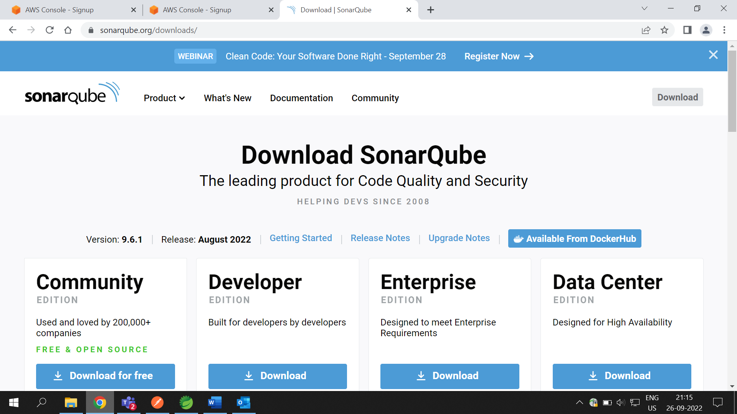

03. It will take time to download the .zip file, after download the zip file keep it in your system by extracting it.

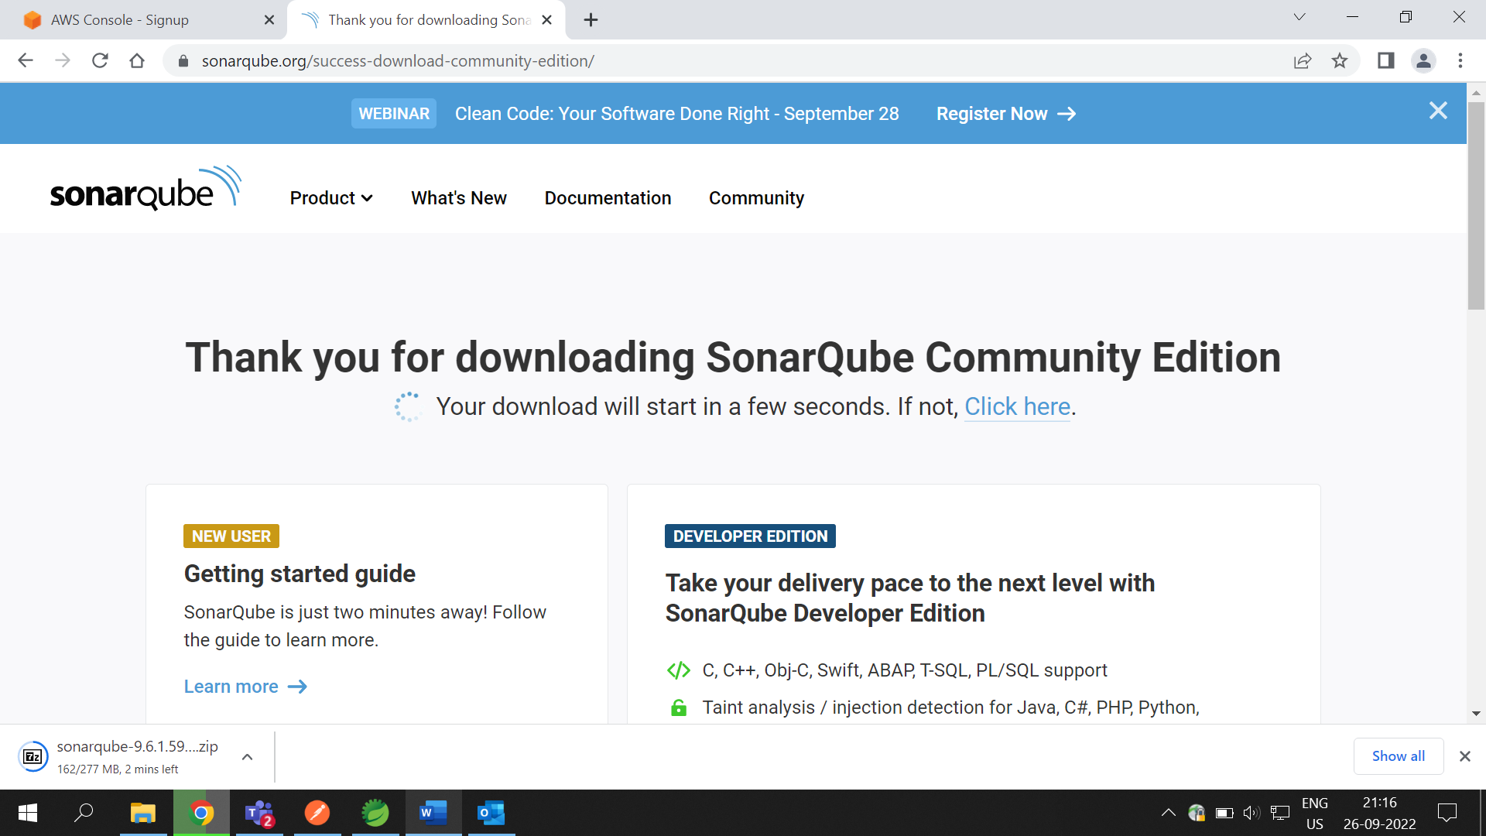

04. Before Running SonarQube add dependency in pom.xml in your project.

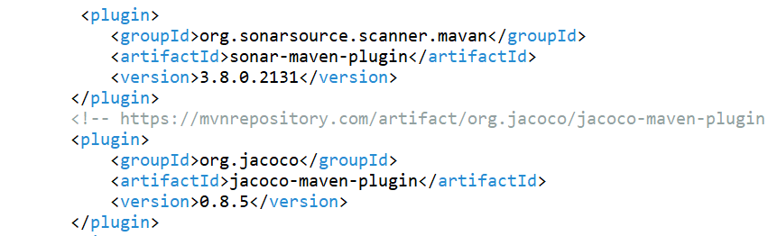

05. Now go to the file location which was extracted.

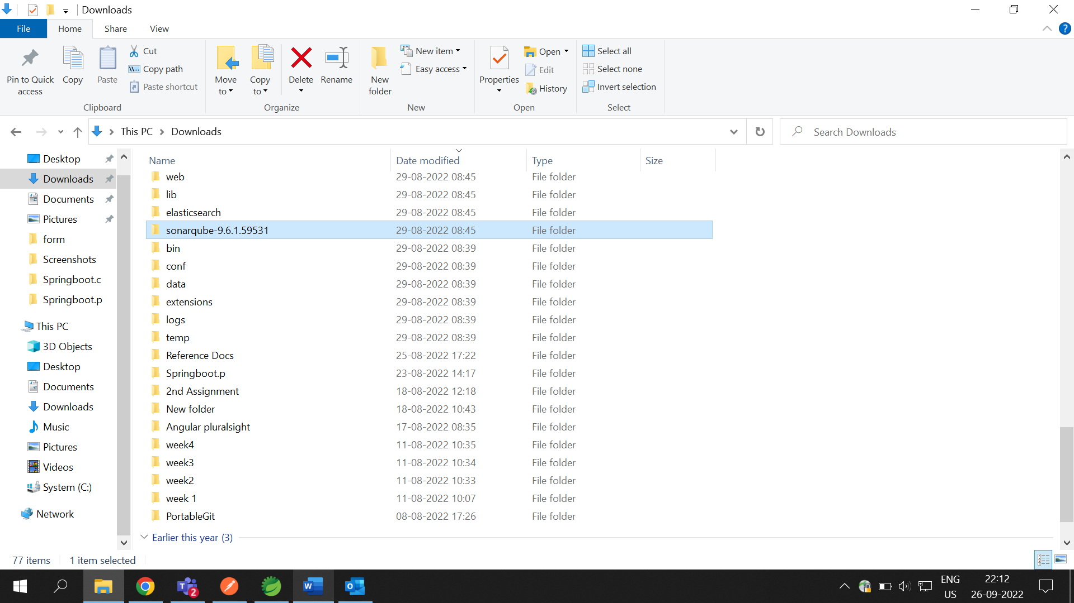

06. Open that***sonarqube*** folder and click on the *bin* folder and open it.

07. Inside that ***bin*** folder go to ***windows-x86-64*** folder and open it. 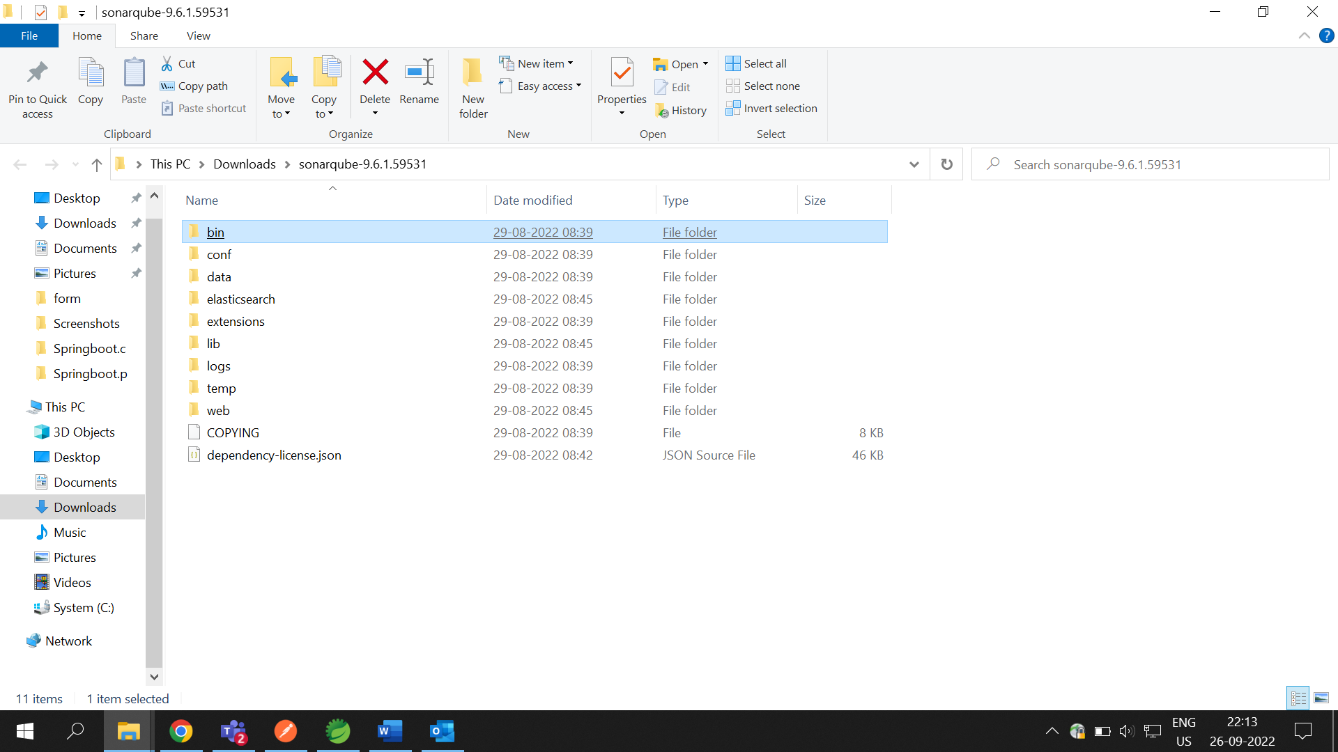

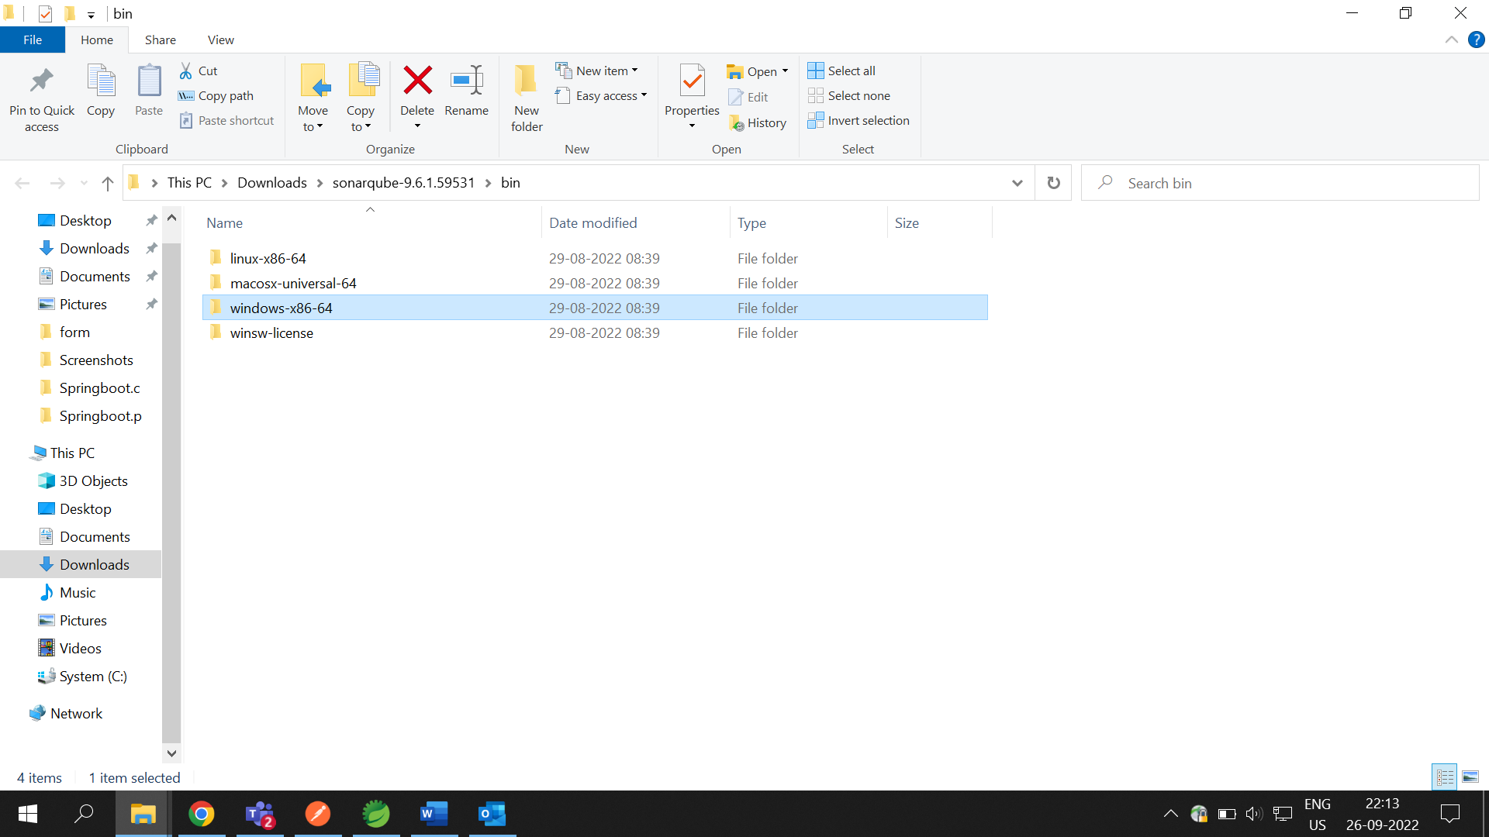

08. Inside that folder you will find a file named ***StartSonar.bat***, just double click on that and open it.

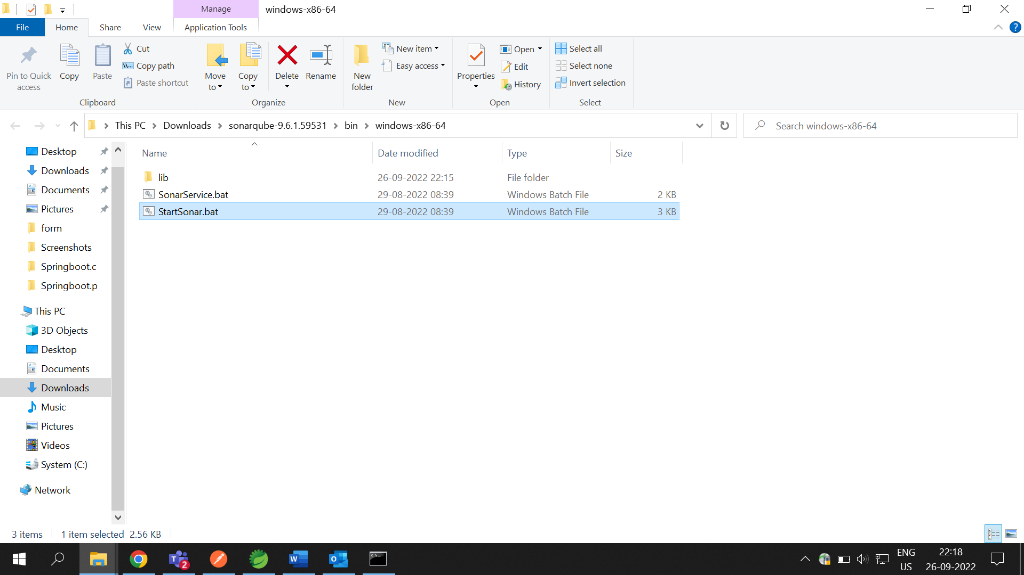

09. After opening of that file, a terminal will open and run that file 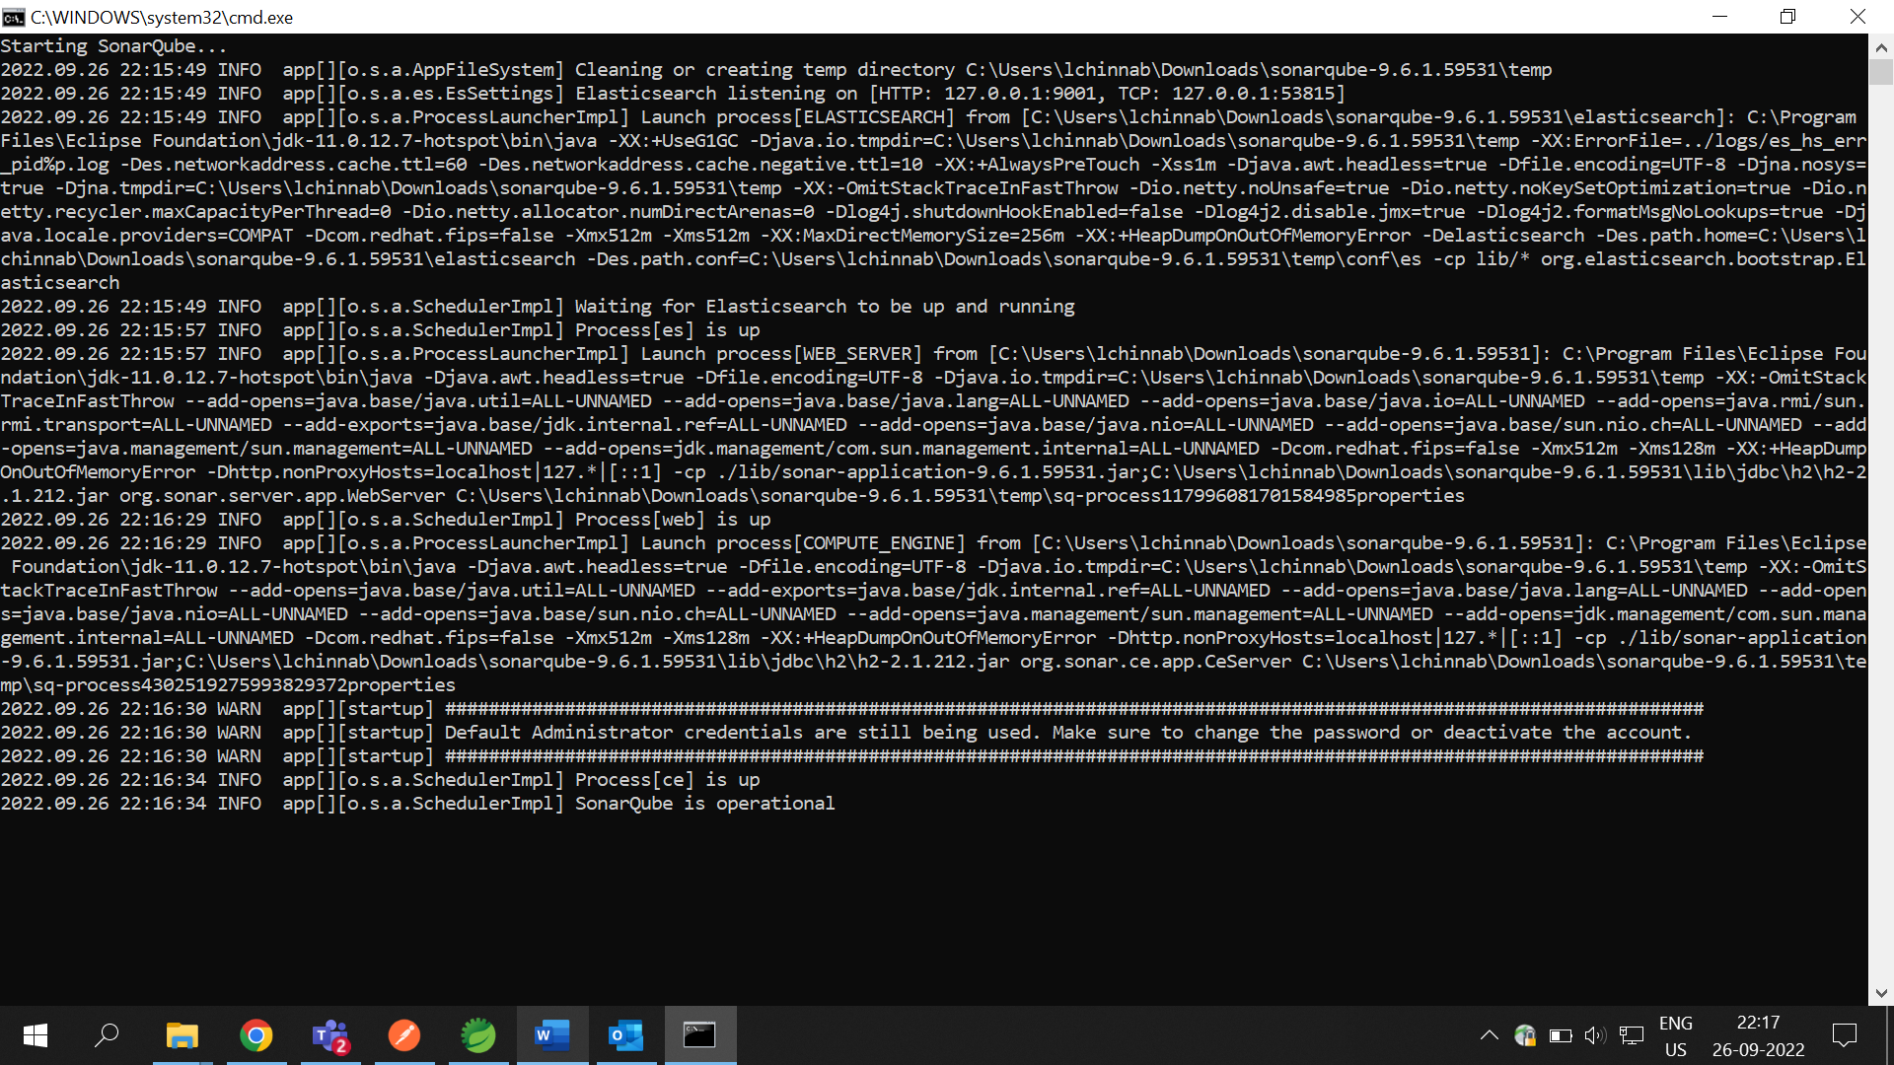automatically, wait for the process needs to be complete.

10. After the completion of that process you just go to your browser and type the default ***url*** of **SonarQube** i.e., [*http://localhost:9000*](http://localhost:9000) on address bar and run it. After running that ***url***, it will ask to give the credentials. Use the default credentials, for username & password you give ‘**admin**’ in both and click on login. 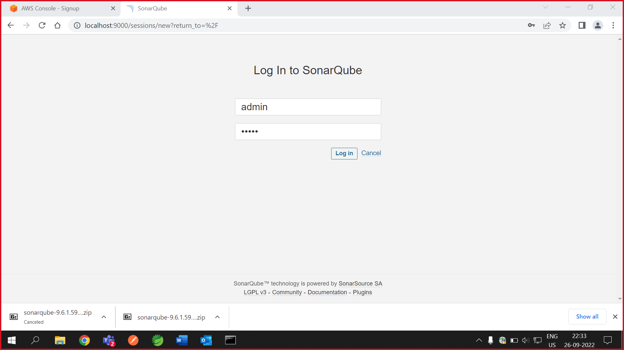

11. Now you need to go to your IDE on which you are working on your project and ***right click on your project - Run as - Maven build***.

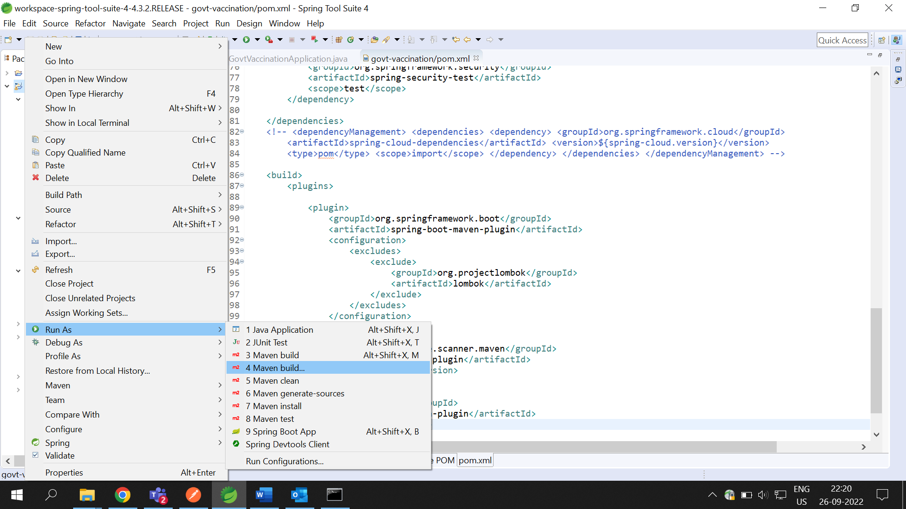

12. Now give command ‘***clean org.jacoco:jacoco-maven-plugin:prepare-agent install***’ on the ***Goals*** section then click on **Apply** and then click **Run**.

13. After successful running, on your console it will give a success message as ‘**BUILD SUCCESS**’.

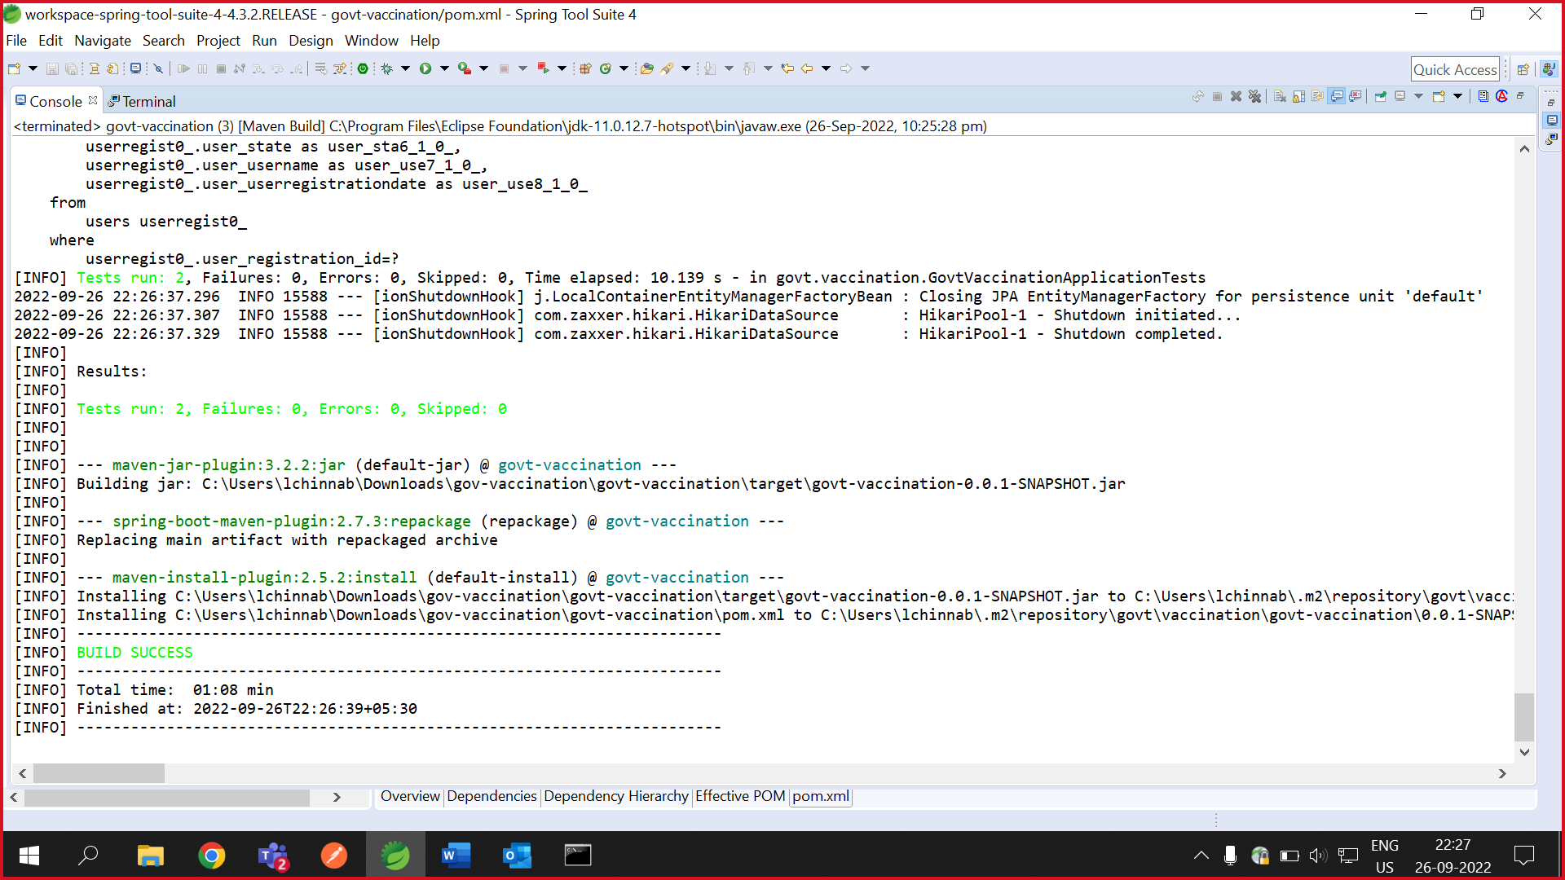

14. Now you go to your browser, where you opened your ***Sonarqube***. Go to the ***profile*** option there and then click on ***My Account*** option. 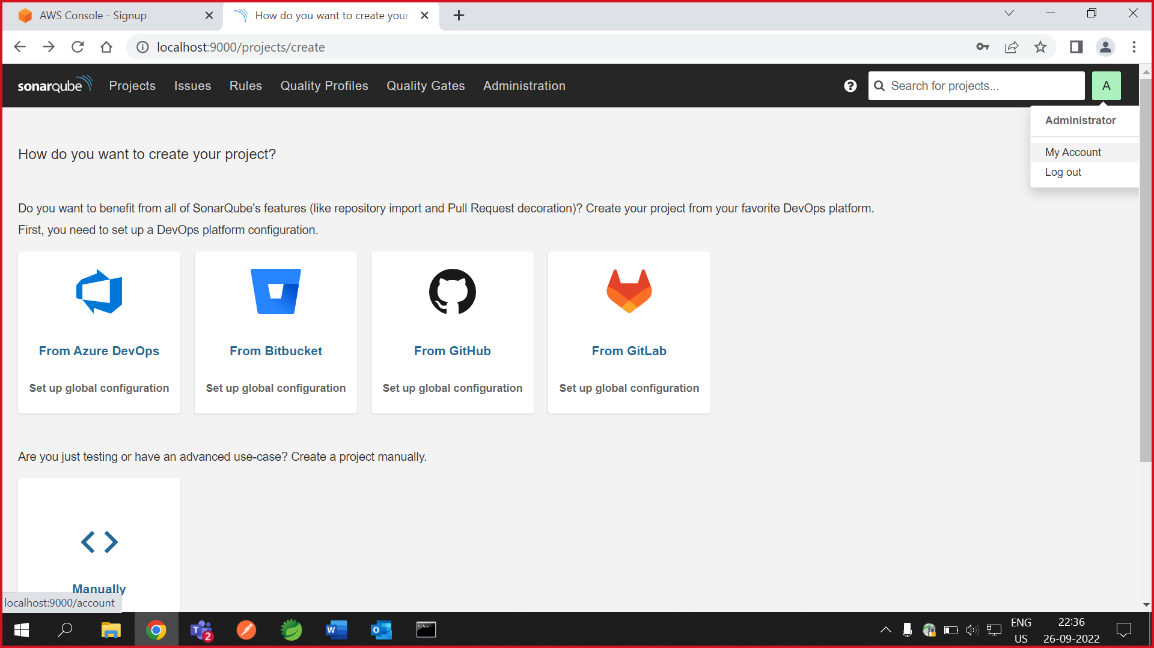

15. Now go to ***security*** and you will find a ***Token*** option will be there with empty filled. You just need to fill the details on respective fields and click on ***Generate*** button to generate a new token for you. 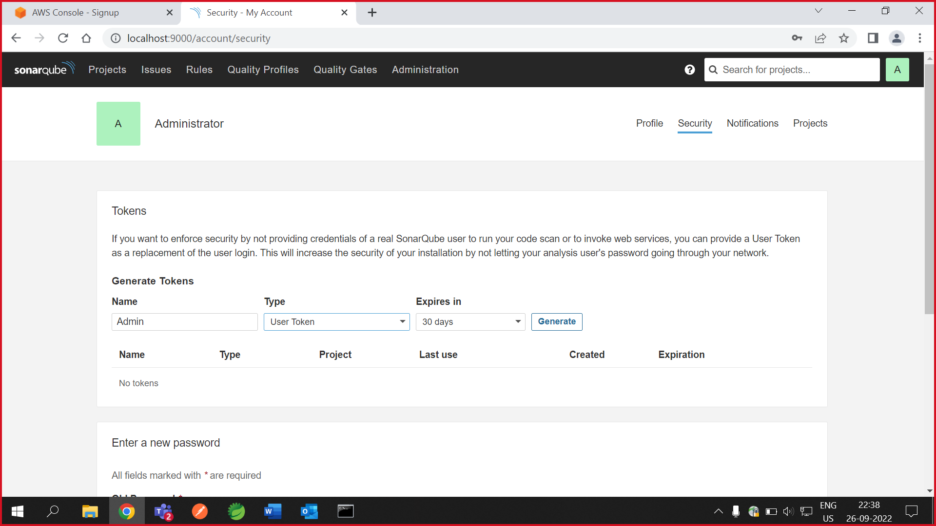

16. Now again you need to go to your project working location and ***right click on your project - Run As - Maven build***.

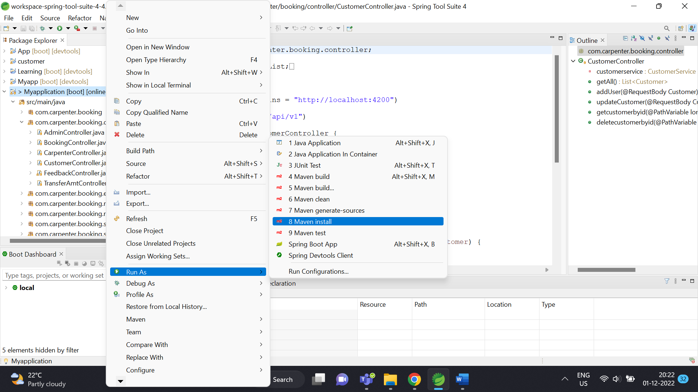

17. Now go to your token you have built and copy that. 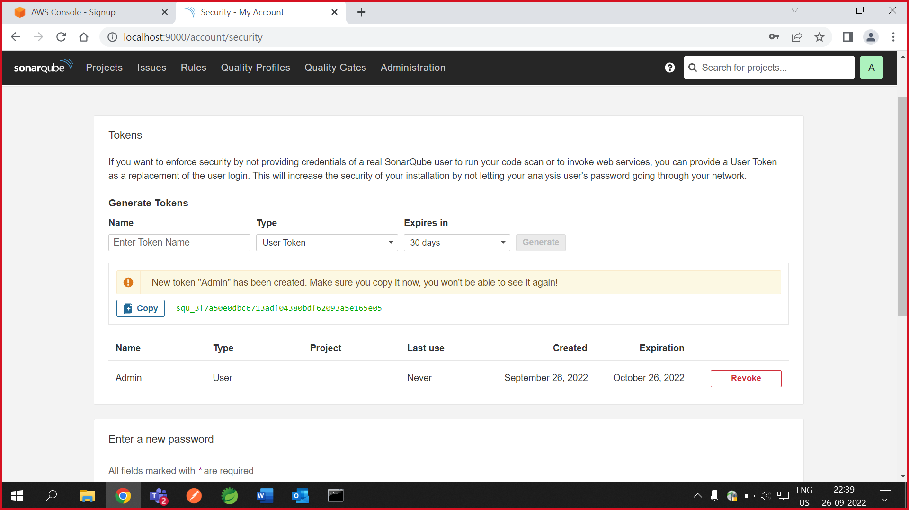

18. Now again go back to your project work location and paste that token on the Goals section along with the command as ***sonar:sonar -Dsonar.login=*** ***squ_380036e64c109ee823b3724b725a5b54a66fc5be***. 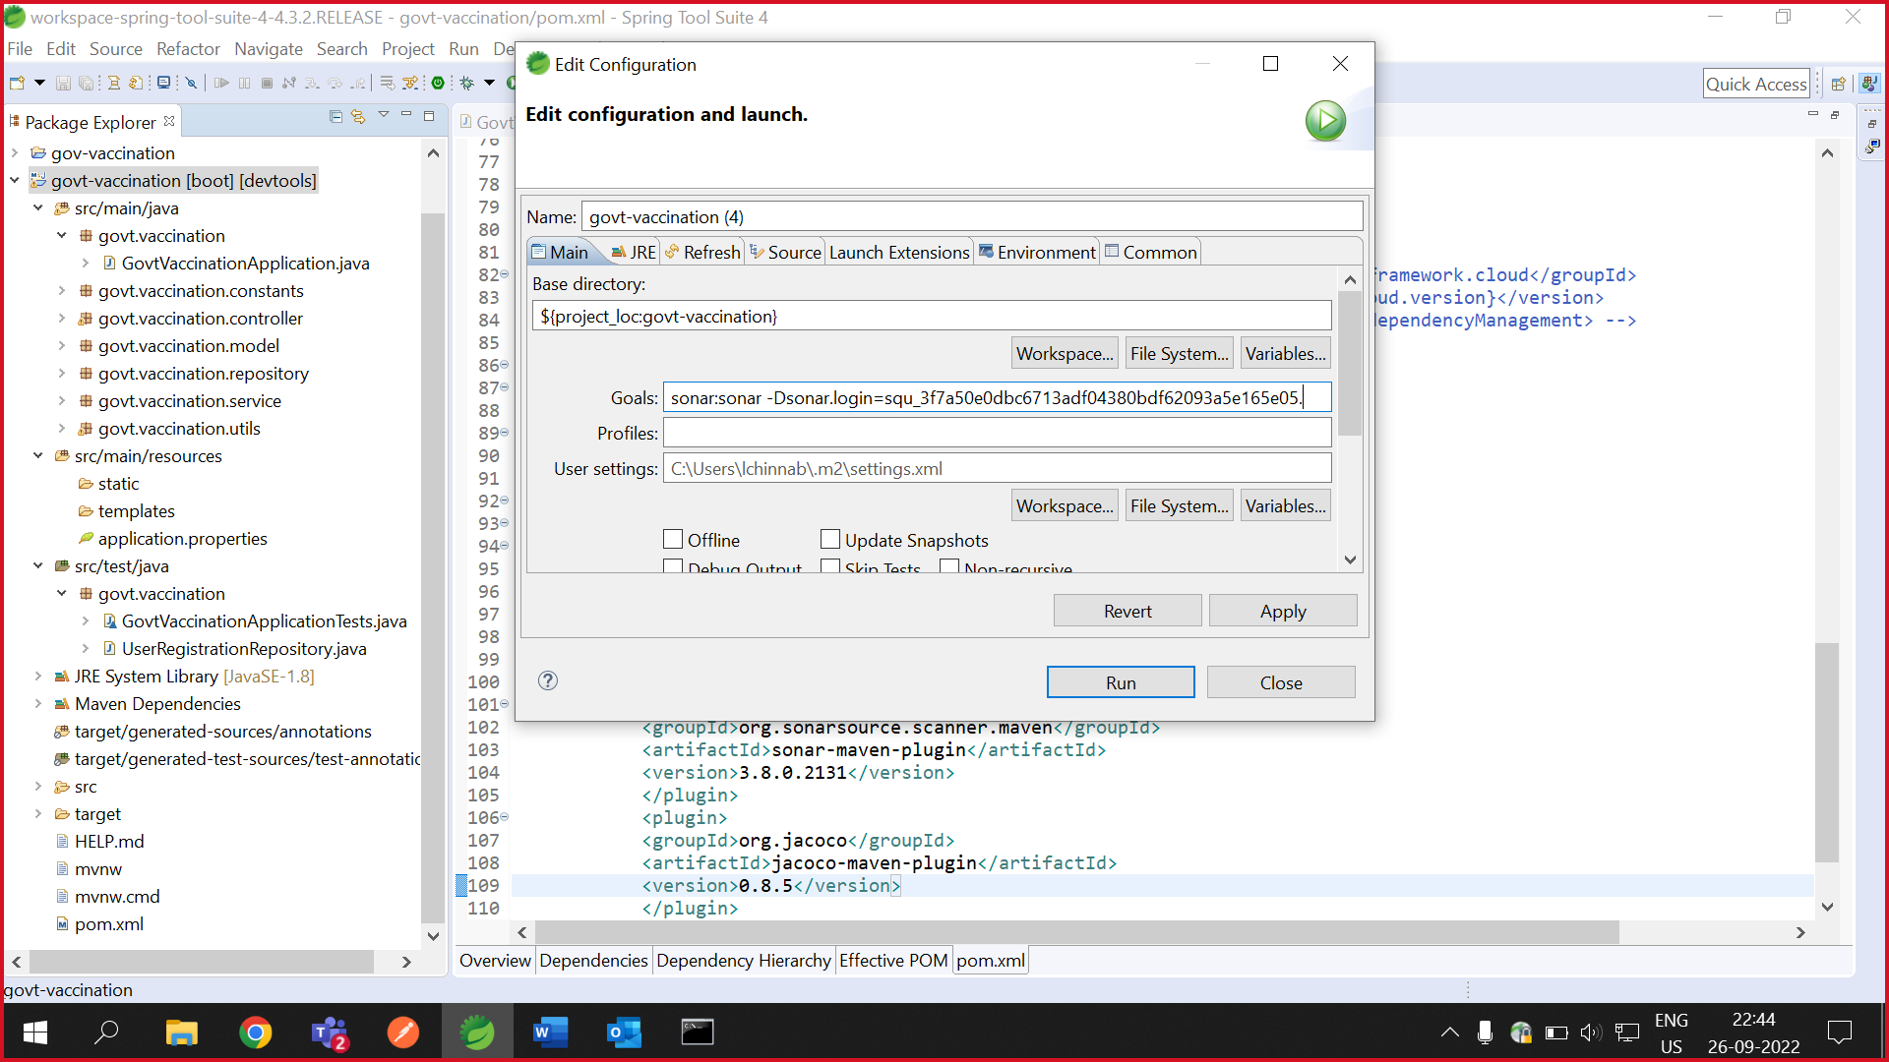

19. Now open your console, there you will get a message like ‘**SUCCESS BUILD**’.

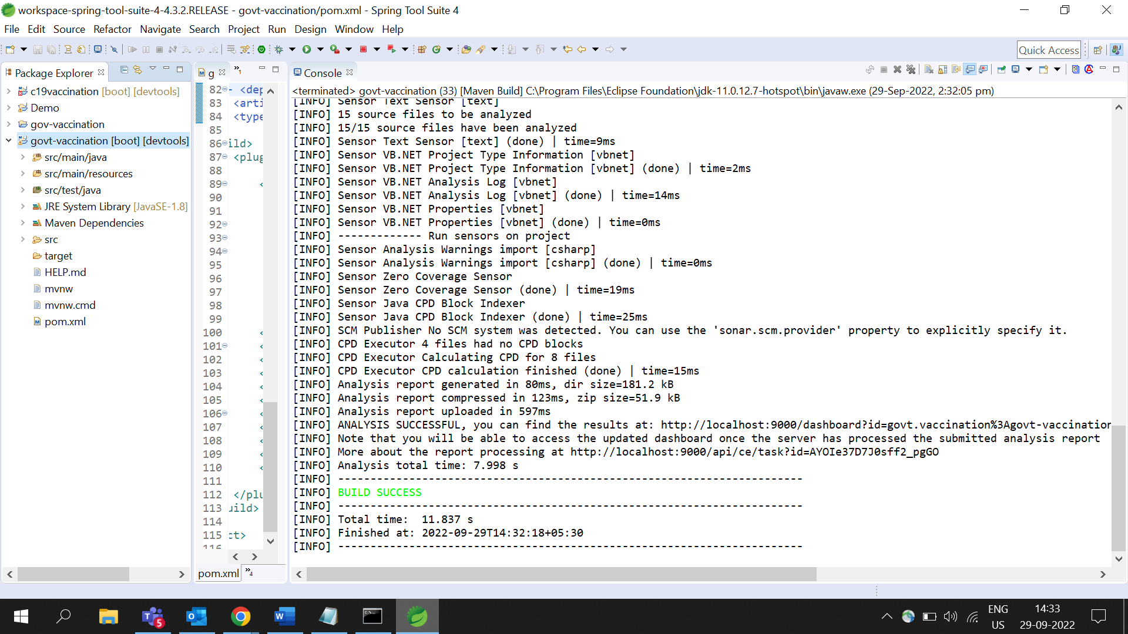

20. Now you go to your browser and reload your page you and then go to your **Projects** option of your ***SonarQube*** page. There you will find ***Project-Dashboard*** with your Project.

21. After fixing all the errors you will get like the below.

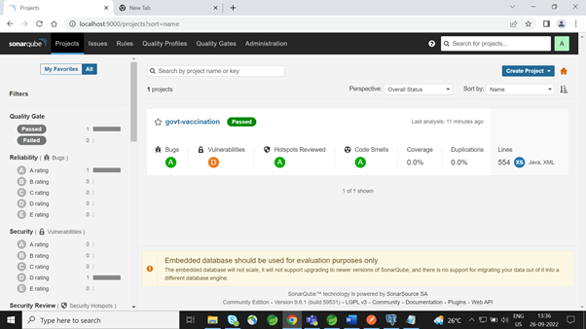

**3. Conclusion:**

SonarQube allows us to have a constant quality inspection of code quality across various quality factors such as Architecture and Design, semantics, bugs, security, duplications, unit tests, cyclomatic complexity etc.